November 2014

Is Change Good? An Integrated Sentinel Monitoring Network (ISMN) for the Northeast Coastal Ecosystems
By Matt Liebman
Environmental Protection Agency
Earth’s climate and its ecosystems have experienced rapid changes in the past 100 years. The Northeast has experienced an increase in the rate of precipitation by 10 to 20% in the past century (http://www.epa.gov/climatechange/science/indicators/weather-climate/precipitation.html), the ocean is warming significantly, and the sea level is rising. Do we see changes in the structure and function of our marine and terrestrial ecosystems and the services they provide in response to these climate drivers? Salt marshes appear to be experiencing increased erosion due to the combined effects of sea level rise and nutrient enrichment. More southerly fish species such as black sea bass (Centropristis striata) and shellfish like the Blue Crab (Callinectes sapidus) are shifting their ranges to the north. We also see dramatic increases in abundance of invasive species, such as green crabs, or tunicates like Didemnum vexillum. Scientists, the government, and journalists are beginning to synthesize these disparate and sometimes anecdotal observations and fit them into our conceptual models of how our ecosystems work. For example, increased ocean temperatures might be causing more stratification in the Gulf of Maine, leading to reduced mixing of nutrients into the euphotic zone (the well-lit surface waters where algae can grow), ultimately resulting in lower primary and secondary productivity. Will this affect fisheries production in the Gulf of Maine? These are the kinds of questions and issues that the Integrated Sentinel Monitoring Network project is grappling with.
The goal of the ISMN is to identify Sentinels and monitoring Sites, to “improve our ability to detect and understand the causes of long-term change in the composition, structure, and function of Northeastern U.S. and Canadian maritime coastal ecosystems.” Sentinels are defined as “a habitat, (abiotic) condition or process, or a species, population or community; its change in state or condition indicates some aspect of ecosystem change.” To evaluate sentinels, we use a suite of indicators — quantitative and physical measures that tells you about the direction of change in the state or condition of the Sentinel. For example, if salt marshes are considered a Sentinel, then the change in state of the salt marsh as measured by aerial extent or vegetation community patterns (the indicator) tells you the salt marsh is changing due to some stressor (e.g. sea level rise). It also indicates there may be important changes in the ecosystem, like potential loss of commercial fish nursery habitat. We plan to link monitoring efforts in salt marshes funded by State of Connecticut, National Estuarine Research Reserve System (NERRS), US Fish and Wildlife Service, National Park Service and National Science Foundation along the northeast coast. Data from nearshore (e.g salt marshes) and offshore sites (e.g. pelagic zooplankton tows) would be compiled and made accessible, and would be analyzed, synthesized and reported through a regional data management, analysis and interpretation center.
The ISMN project combines efforts of Northeast Regional Association of Coastal Ocean Observing Systems (NERACOOS) and the Northeast Regional Ocean Council (NROC) and follows work conducted for the Long Island Sound Study. For example, we are building upon a database to track monitoring programs from the Long Island Sound Sentinel Monitoring for Climate Change Program. The records in the database shall be used to identify compatible monitoring programs, monitoring similar indicators in order to identify a monitoring network that provides regional coverage. With seed funding from NOAA, this project has brought together over 50 scientists from over 30 partner organizations from government (e.g. EPA), academic (e.g. Suffolk University), partnerships (e.g. Gulf of Maine Council on the Marine Environment EcoSystem Indicator Partnership) and nonprofit organizations (e.g. Nature Conservancy). Workgroups based on estuarine, benthic and pelagic habitats, have been formed to identify and prioritize specific Sentinel (and indicators and monitoring sites). We are selecting Sentinels that best represent critical ecosystem functions, are expected to change based on climate change drivers, or have long term monitoring records.
We have held several workshops to date including one on November 12, 2014 and are planning to complete a Science and Implementation Plan by spring 2015. This plan will be the basis for seeking funding from governmental or nonprofit funding organizations to make enhancements to existing monitoring sites/programs and possibly create new monitoring locations to help fill the gaps along the northeast coast. The National Climate Assessment released in May 2014 as part of the U.S. Global Change Research Program (USGCRP) mandates scientists to “assist the Nation and the world to understand, assess, predict, and respond to human-induced and natural processes of global change.” The President’s Climate Action Plan from 2013 charged agencies to prepare for and assess impacts of climate change. In the next few years, we hope that with funding of the plan, we’ll at least be able to understand how marine ecosystems are changing, and be in a better position to adapt to and manage marine resources of the future.
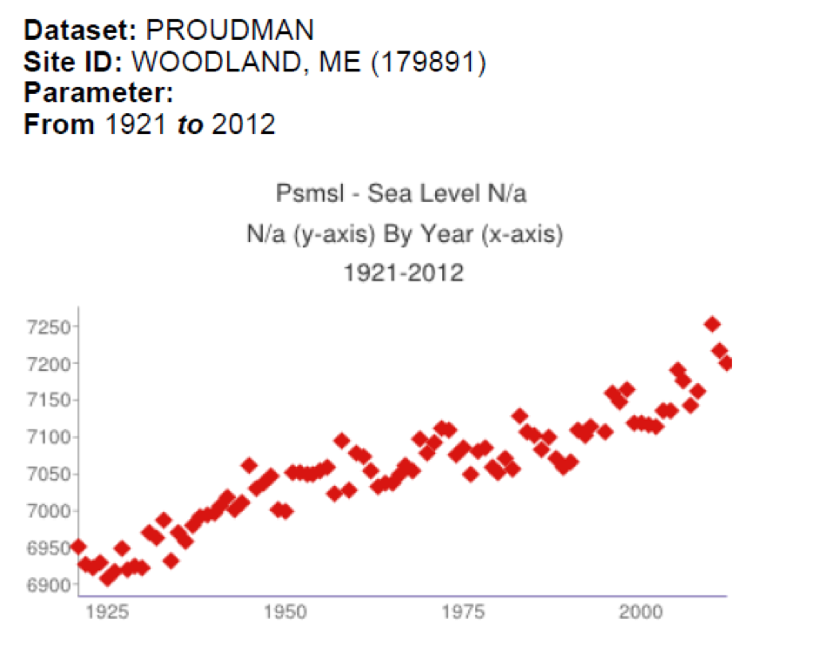
Graph from the EcoSystem Indicator Partnership Indicator Reporting Tool (www.gulfofmaine.org/esip/reporting).
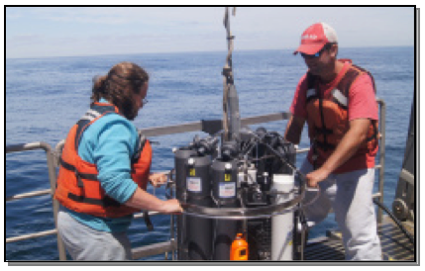
Picture courtesy of Jeffrey Runge, Gulf of Maine Research Institute.

