May 2014 ESIP Journal

Climate Outlook
The Gulf of Maine Council’s Climate Network recently launched a new quarterly e-bulletin highlighting a product collaboratively developed by US and Canadian meteorologists through the North American Climate Services Partnership—the Gulf of Maine Quarterly Climate Impacts and Outlook (GOM Outlook). Modeled after a similar publication in the Great Lakes region, the GOM Outlook provides an engaging snapshot of recent weather events and anomalies; illustrates regional weather impacts on ecosystems and the economy; and offers a forecast for the coming three months.
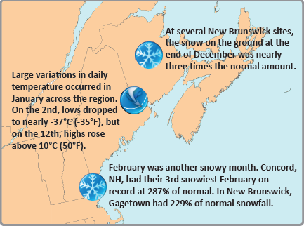
At last September’s meeting of the Climate Network, participants voiced the need for more “downscaled” climate data and forecasting—to better understand how global climate trends are playing out regionally in terms of air and sea temperature changes, precipitation patterns, and extreme weather events. The GOM Outlook now offers credible and current climate data every March, June, September and December to those who must apply that information in fields such as farming, forestry, fishing, transportation, emergency management and public health.
The Climate Network is publicizing the new GOM Outlook through Gulf of Maine Council partners and others. To receive the quarterly GOM Outlook and Climate Network e-bulletin (which provides additional updates on climate-related resources and events in the region), please sign up at http://www.gulfofmaine.org/2/climate-network-climate-outlook/

