March 2014 ESIP Journal
Title: What the Hake?! Fish Forensics in Maine Markets
A collaborative effort to use fish forensics for quality assurance testing of fish fillets in Maine markets.
Mislabeling of seafood is a widespread issue, not just locally but worldwide. Mislabeling is a multifaceted issue encompassing human health and consumer rights concerns—not to mention it is an illegal practice in the US. The most severe health concerns associated with mislabeling include exposure to allergens and toxins (e.g. tetrodotoxin in pufferfish and gempylotoxin in escolar) as well as high levels of mercury present in certain species of fish. The fraudulent substitution of lower-quality fish in place of higher quality (read: expensive) fish is also a frequent problem. While the extent of fish mislabeling varies substantially based on the product and location of sale, numerous studies, surveying both restaurants and retail markets, have reported over 30% mislabeling across samples tested. DNA testing for identifying mislabeling of seafood products has been used by a wide range of individuals from high school students¹ to high-profile ocean activist groups² and independent research labs.
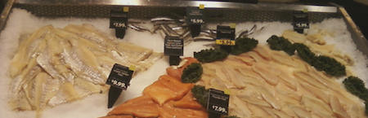
Fish filets on display in a Maine supermarket. Photo: Laura Whitefleet-Smith (2/2014)
Researchers at the University of New England are particularly interested in commercially sold hake and have developed a molecular method for identifying six species of hake and an additional five groundfish species common to the Gulf of Maine. Hakes are intriguing as the name “hake” describes a number of different species belonging to multiple families of fish. According to the 2013 FDA Seafood List, there are nine species of fish that may acceptably be labeled under the name “hake.” The use of this ambiguous label invokes a number of questions. Why are all of these species grouped together under one label? What are you getting when you purchase hake in the Gulf of Maine? University of New England graduate student Laura Whitefleet-Smith and Assistant Research Professor Anna Bass have embarked on a project to address these questions by working collaboratively with local markets to achieve two main goals: 1) quality assurance testing of fish fillets and 2) determining the species composition of hake sold in Maine markets.
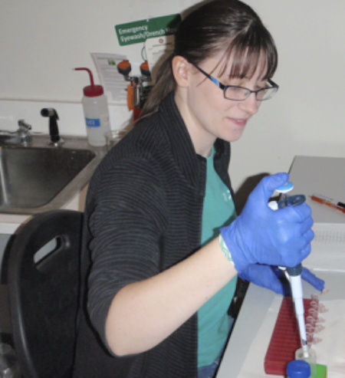
Graduate student and co-investigator Laura Whitefleet-Smith isolating DNA from fillet samples donated by a local supermarket. Photo: Christopher Goodchild (3/2014)
The technique used by UNE researchers is a lower-cost alternative to popular DNA barcoding which relies on expensive sequencing. In the future, this technique could be used as a means of monitoring the species composition of hake in our markets over time. Interestingly, several hake species have shown distributional changes over the past 45 years that may be related to increasing water temperatures³. This could result in an alteration of the hake species composition in the Gulf of Maine. Detecting changes in the species composition of hake in our markets could represent a valuable indicator of possible distributional changes in wild hake stocks. The ability to detect spatial changes in mobile species’ ranges is crucial to our understanding of the ecological impacts of the warming waters in both the Gulf of Maine and our oceans as a whole.
Looking for more? Contact us at: http://www.une.edu/faculty/profiles/abass.cfm
1.) http://www.nytimes.com/2008/08/22/science/22fish.html?_r=1&
2.) http://oceana.org/en/our-work/promote-responsible-fishing/seafood-fraud/overview
3.) Nye, J.A., Link, J.S., Hare, J.A., et al. 2009. Mar. Ecol. Prog. Ser. 393:111-129

