January 2014 ESIP Journal
The Gulf of Maine Council’s Climate Network is launching several new initiatives following its high-energy September meeting in Orono. Maine. More than 60 professionals shared two fast-paced days discussing climate impacts in forestry, land use and marine fisheries along with extreme weather effects on coastal infrastructure. Across sectors and borders, many shared needs emerged—to apply research to local communities and promote best practices; to monitor for long-term climate changes an impacts; to have detailed maps and forecasting at regional and local scales; and to have better cost-benefit analyses and socio-economic data for adaptation planning.
Many recommendations emerged for future Climate Network projects—including creation of an online informational clearinghouse for climate data and adaptation guidance; compilation of standardized and consistent land-based datasets; support of high-resolution mapping; and promotion of climate change best practices. One recommendation applied directly to ESIP’s work—a request for a list of indicator species to monitor how climate change is affecting Gulf of Maine marine life. The Climate Network will soon have more resource-rich web pages (sharing the same site design as ESIP’s pages), and is compiling examples this winter on low-cost adaptation measures being used by municipalities.
Presentations from the September meeting can be found on the CN web pages of the GOMC website: http://www.gulfofmaine.org/2/committees-and-programs/climate-change-network/. More on low-cost adaptation measures can be found in a recent NOAA study, Cost-Efficient Climate Adaptation in the North Atlantic report— www.seagrant.uconn.edu/CEANA/.
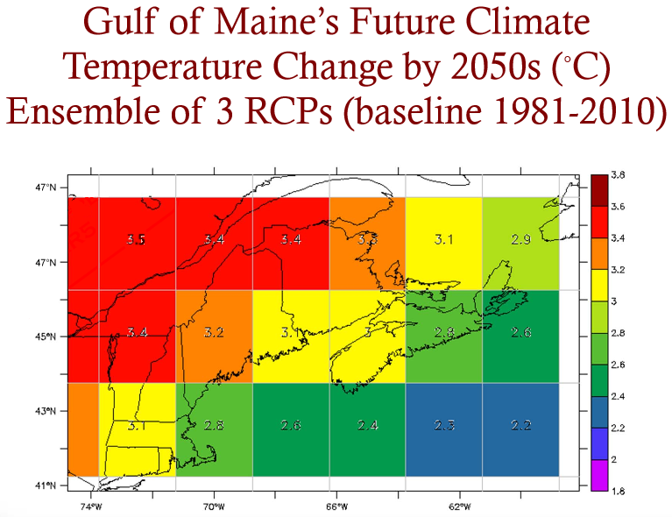
Graph: Adam Fenech, Ph.D. (UPEI Climate Lab)

