December 2013 ESIP Journal
U.S. Department of the Interior supplemental funds following the devastating regional impacts of Hurricane Sandy will be used in New England to update coastal elevation data. From New Hampshire to Rhode Island, LiDAR flights will collect high-resolution 3D Elevation Program (3DEP) data that builds on regional collection in 2012 and fills in gaps remaining subsequent to the 2012 flights. The USGS 3DEP data produces 1 foot contours and has a goal to update topography and hydrography data on an eight- year cycle.
The primary goal of 3DEP is to systematically collect enhanced elevation data in the form of high-quality light detection and ranging (lidar) data over the conterminous United States, Hawaii, and the territories on an 8-year schedule. Interferometric synthetic aperture radar (ifsar) data will be collected over Alaska, where cloud cover, the large area, and the remote location preclude the use of lidar over much of the State. The enhanced elevation data support flood-risk management, natural resources conservation, infrastructure management, agriculture and precision farming, aviation safety, renewable energy development, and many other identified business applications.
For the Gulf of Maine, the availability of high resolution topographic data will improve models that forecast impacts of future storms and projected sea level rise on vulnerable communities, ecosystems, and infrastructure. Tools like the recently released Northeast section of NOAA’s Sea Level Rise and Coastal Flooding Impacts Viewer http://www.csc.noaa.gov/slr/viewer/# will incorporate the revised elevation data to refine and better portray potential impacts.
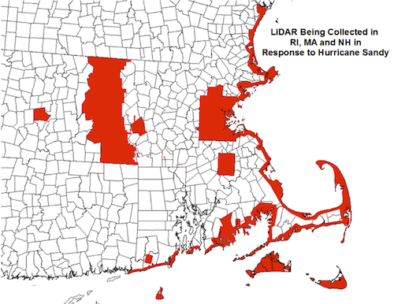
Areas in red will be collected in 2014. A seamless coastal data set from New Hampshire through Rhode Island will be included in the USGS Coastal National Elevation dataset (CoNED) as well as in 3DEP. Large interior blocks include individual municipalities and counties that provided matching funds.

