July 2013 ESIP Journal
The SPARTACUS GK-12 Project at the University of New England
By Charles Tilburg, Susan Hillman, Henrietta List, and Stephan Zeeman
The University of New England (UNE) will welcome its fourth and final cohort of Graduate Fellows to the National Science Foundation SPARTACUS GK-12 project in the Department of Marine Sciences this August. Led by Stephan Zeeman, Susan Hillman, and Charles Tilburg of UNE, the SPARTACUS (Systemic PARTnership Aimed at Connecting University and School) GK12 project focuses on the hydrologic cycle in a coastal watershed and conveys the importance of interdisciplinary efforts in scientific and social issues to K-12 students and teachers through the work of graduate students pursuing a MS in Marine Sciences at UNE.
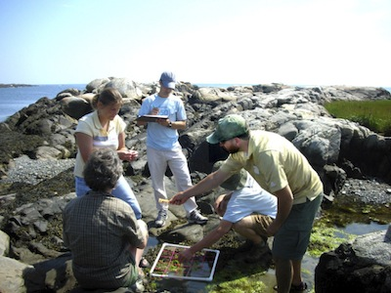
SPARTACUS Fellow Caitlyn Little (MS 2012) with K-12 teachers inspecting a tidal pool.
Current research and understanding of the interrelationships of physics, chemistry, biology, mathematics, and geology are shared by these Graduate Fellows in classrooms. Using the settings of a local watershed and UNE’s Saco River Coastal Observing System (SaRCOS), Graduate Fellows share their roles in investigating the science of the Saco River watershed. As a result, K-12 students get a clear picture of how science applies to their lives.
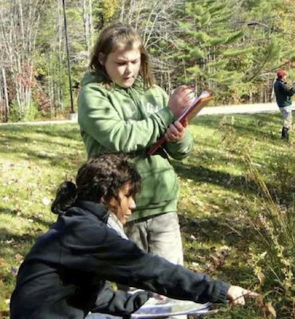
SPARTACUS Fellow Kylie Bloodsworth (MS 2013) with a Massabesic Middle School student.
Through the collaboration of Graduate Fellows and Host Teachers, SPARTACUS provides Graduate Fellows with an opportunity to gain an understanding of the educational process, develop communication skills and team building, and appreciate the importance of K-12 outreach as a professional commitment. K-12 students and teachers are given the opportunity to participate in authentic inquiry-based, locally-relevant research. This place-based inquiry engages even reticent science students in active learning. This unique project brings together school districts’ needs, scientific research, and place-based inquiry education. Schools benefit from professional development of teachers, and enrichment of the learning environment, while society gains greater scientific and technical literacy.
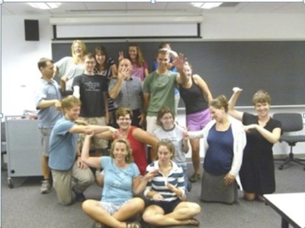
SPARTACUS fellows and Host teachers, 2012-2013 year.
The schools encompass rural to urban settings, including Maine’s largest and most ethnically diverse district. School districts participating include: Portland Public Schools, RSU 23 (Saco, Dayton and Old Orchard Beach), Biddeford School District, MSAD 6 (Buxton, Hollis, Limington, Standish, and Frye Island) and RSU 57 (Alfred, Limerick, Lyman, Newfield, Shapleigh, Waterboro). For next year, we will partner with the LearningWorks afterschool programs (http://www.learningworks.me/) in Portland, Falmouth and Biddeford to provide students in grades 3-5 and high school with opportunities for achieving academic success.
In the last four years, the program has provided needed communications training to 22 graduate students from UNE and reached 2162 K-12 students within Maine. For more information on the program please contact Stephan Zeeman at 207-602-2410 or (szeeman@une.edu) or visit our web page at (http://www.une.edu/cas/marine/spartacus.cfm).

