June 2013 ESIP Journal
FSRS-GOMLF Collaborative Lobster Science Workshop
Promotes International Collaboration in Lobster Research
By Patty King
The Fishermen and Scientists Research Society (FSRS) and the Gulf of Maine Lobster Foundation (GOMLF) held their bi-annual Collaborative Lobster Science Workshop on February 19, 2013 in Truro, Nova Scotia. The theme of this year’s workshop was Promoting International Collaboration. The goal of the workshop was to gain a better understanding of the different types of research taking place on both sides of the border and to identify opportunities for cross-border collaboration.
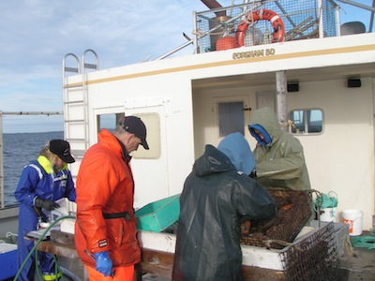
Photo courtesy of Tricia Pearo
Attended by more than 120 fishermen and scientists from both Canada and the US, the workshop included a diverse series of presentation, dealing with everything from determining age of lobster, size at maturity, larval production and settlement and lobster moult and quality, to alternative baits and efforts to address growing concerns about derelict fishing gear. Copies of the presentations will be available at http://www.fsrs.ns.ca/workshops.html in the near future. A workshop report is also being prepared and will be available in early summer on the FSRS website and in hard copy upon request.
Lobster Collector Project
One of the projects highlighted at the workshop was the FSRS Lobster Collector Project, a collaborative project between the FSRS and Fisheries and Oceans Canada (DFO) formed to better understand the settlement of Stage-IV lobsters in deep and shallow areas at selected regions along the coast of Nova Scotia. Settlement collectors using a design from Richard Wahle and co-workers in the United States were first deployed in Lobster Bay (Argyle) in 2007. The objective of the project is to develop an indicator of settlement strength. The collectors are also a potential tool for biodiversity research, which enables us to study ecosystem interactions such as predation.
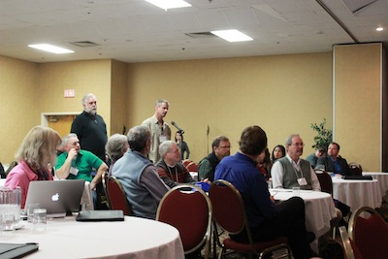
The FSRS Lobster Collector Project is part of a larger international collaborative effort which has resulted in the largest scale synoptic view of lobster settlement ever conducted, from Rhode Island to Newfoundland. The regional projects are working together through the American Lobster Settlement Index (ALSI) Collaborative. Canadian ALSI collaborators, including the FSRS, DFO and the University of New Brunswick, are working with US ALSI collaborators led by Rick Wahle at the University of Maine to better understand the dynamics of settlement of American lobster and to develop an index on annual settlement that will be useful for predicting future recruitment into the lobster fishery. The work in Canada complements an index of lobster settlement in the US that has been measured in several locations for more than 20 years.
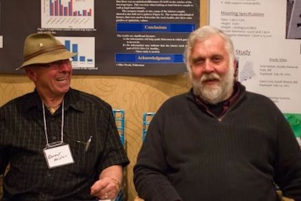
FSRS Celebrates 20 Years of Collaboration
On February 20-21, 2013, following the collaborative lobster science workshop, the FSRS held it 20th Annual Conference, celebrating 20 years of collaboration between fishermen and scientists. Established in January 1994, the Fishermen and Scientists Research Society (FSRS), a non-profit organization, is an active partnership between fishermen and scientists. The FSRS was developed with the overall objectives to promote effective communication between fishermen, scientists and the general public, and to establish and maintain a network of fishermen and scientists capable of conducting collaborative research and collecting information relevant and necessary to the long-term sustainability of marine fisheries. The current membership consists of 489 members, including 277 fishermen members and 212 scientists/other members.
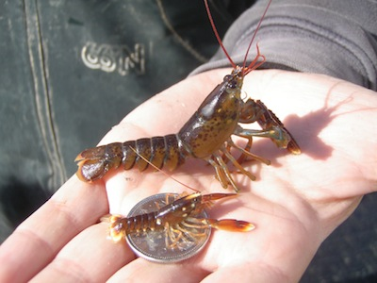
Photo courtesy of Tricia Pearo
To learn more about the FSRS and its numerous research projects and communication/outreach activities please check out our website at www.fsrs.ns.ca or contact Patty King, FSRS General Manager, at info@fsrs.ns.ca, 902-876-1160.

