November-December 2011 ESIP Journal
Community Counts
Justin Huston
A key challenge that coastal decision-makers face is the disconnect between environmental information and socio-economic information. Most socio-economic info is collected and presented by political boundary (e.g. municipality, county, etc.) versus watershed or coastal area, and this makes it difficult to show the connection between ecosystem health and socio-economic health.
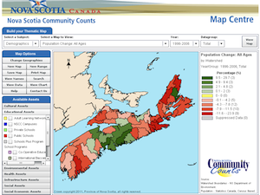
Figure #1
Along these lines, I thought the ESIP community would be interested in the Government of Nova Scotia’s recent success in making socio-economic data available by watershed. Through the NS Community Counts website (www.gov.ns.ca/finance/communitycounts), the public can now find and download census data and other socio-economic data for the 46 primary watersheds across the entire province. Efforts are currently underway to add the secondary watershed level.
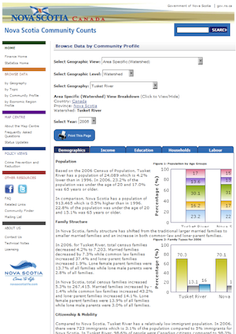
Figure #2
I encourage you to visit the site and take 10 minutes to explore the site. Pretty quickly you’ll realize the power of this approach. There are a variety of ways that you can look at socio-economic information by watershed, including the Map Centre (figure 1), Watershed Profiles (figure 2), and watershed comparisons (figure 3). As well the actual data is easily accessible and downloadable for those that want more detail or to play with the data.
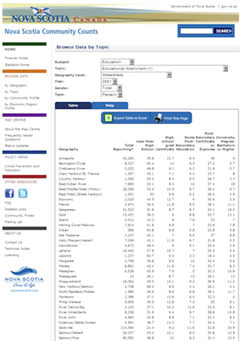
Figure #3
Community Counts is a program located within the Economics and Statistics division of the Nova Scotia Department of Finance, established to develop a statistical infrastructure system of information about Nova Scotian communities. For more information contact Malcolm Shookner, Director of Community Counts, at shooknmr@gov.ns.ca“

