April-May 2011 ESIP Journal
How is Casco Bay, Maine Doing?
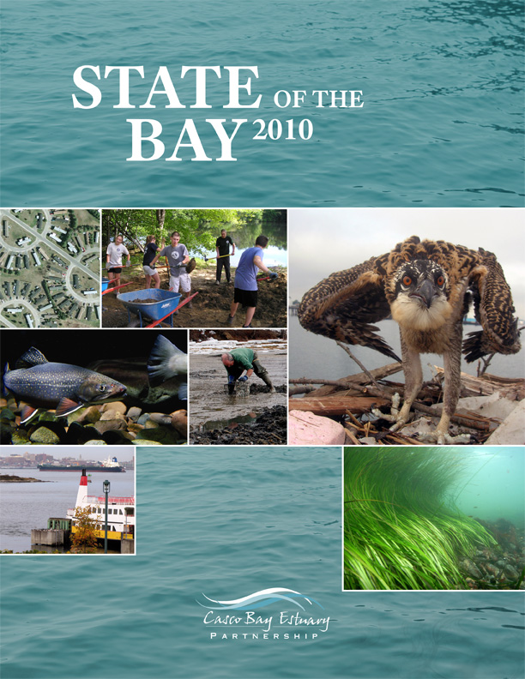
The State of the Bay 2010 report presents a comprehensive picture of the health of Casco Bay and its watershed. The report is available at http://www.cascobay.usm.maine.edu/sotb10.html
The State of the Bay 2010 report, released in October, presents an assessment of the overall health of Casco Bay and its watershed. The report is produced every five years by the Casco Bay Estuary Partnership, one of 3 National Estuary Programs (NEPs) in the Gulf of Maine region. (The others are the Piscataqua Region Estuaries Partnership and the Massachusetts Bays Program). Each NEP is made up of diverse federal, state and local partners and receives major support from the U. S. Environmental Protection Agency. State of the Bay 2010 bases its assessment of Casco Bay on a series of 18 environmental indicators many of which are shared with ESIP. These indicators address Population; Impervious Surface; Stormwater; Combined Sewer Overflows; Pathogen Pollution of Beaches and Shellfish Beds; Bay Water Quality; Inland and Estuarine Water Quality; Toxic Pollution in Mussels and Sediments as well as Contaminants of Emerging Concern; Interior Forest Habitat; Conserved Lands; Living Resources including Eelgrass, Waterbirds, and Invasive Species; Climate Change, Sea Level Rise & Ocean Acidification; and Stewardship.
The report finds that, overall, Casco Bay is largely healthy. The Bay supports a remarkable abundance of fish, birds, and wildlife. Its watershed remains predominantly forested, and many of its streams are home to native fish and invertebrates. Over the past generation, concentrations of many toxic compounds in the Bay’s surface sediments have declined, and less human waste now enters the Bay from combined sewer overflows and overboard discharges. The report also notes, however, that there are problems on the horizon. The region’s population continues to grow, and that growth has been concentrated in peripheral communities. Such a dispersed development pattern changes the character of rural communities, strains municipal and state budgets, and risks degrading water quality, wildlife habitat, and aesthetic quality. Other looming threats include continued bacterial pollution of beaches and shellfish beds from nonpoint sources, nutrient over-enrichment in parts of the Bay, increased numbers of invasive species in marine and fresh waters, and the uncertain effects of climate change and contaminants of emerging concern.
The work of the Casco Bay Estuary Partnership continues to support the habitat protection and restoration goals of the Gulf of Maine Council, as well as working to foster environmental and human health. At a State of the Bay workshop held October 21, 2010 participants discussed ongoing and future efforts to benefit Casco Bay, its watershed, and the region’s human and natural communities. To learn more about the Casco Bay Estuary Partnership, its many participating organizations, and its ongoing projects and products, visit http://www.cascobayestuary.com/

