March-April 2010 ESIP Journal
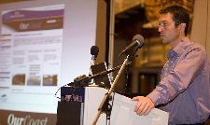
Justin Huston, an active member of the Coastal Development Subcommittee.
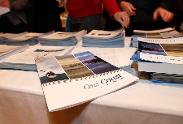
Images from the press conference releasing the State
of Nova Scotia’s Coast Report.
In December 2009, the Government of Nova Scotia released the first-ever
State of Nova Scotia’s Coast Report. The Report looks at the current
state of six issues, which the Government of Nova Scotia has identified
as coastal management priorities: coastal development; working
waterfronts; public coastal access; sea level rise and storm events;
coastal water quality; and coastal ecosystems and habitats. Baseline
information on these issues, as well as to inform the development of a
provincial Coastal Strategy, is targeted for release in late 2010.
This work is being undertaken by the Provincial Oceans Network, an
interdepartmental body composed of 15 provincial departments and
agencies with a mandate and interest in coastal management. The PON
Secretariat is housed within the department of Fisheries and Aquaculture
and is chaired by Justin Huston, who is also an active member of ESIP.
“Our focus on the state of specific coastal issues lines up very well
with ESIP’s approach to regional indicators, and this is no
coincidence. Participation on the Gulf of Maine Council and in ESIP,
has really helped to shape our approach to coastal management here in
Nova Scotia.”, says Mr. Huston, “ESIP has brought together a level
of expertise and quality of information that no single province or state
could accomplish on its own. Collaborative approaches like ESIP are the
future of coastal management.”.
What’s next for Nova Scotia? Public consultation on the Report and
the future Coastal Strategy begins this Spring. The Report can be
downloaded online, where the public can access the full technical
report, a 20 page summary document and six coastal fact sheets. The
public is also encouraged to provide feedback on the Report via an
online questionnaire.
www.gov.ns.ca/coast
Social Media Release: http://gov.ns.ca/news/smr/2009-12-10-coastal.asp

