August-September 2009 ESIP Journal
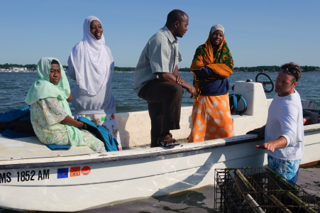
In Duxbury Bay: Â John Brawley explains oyster nursery methods to a group of scientists and shellfish farmers who were recently visiting New England from Zanzibar, Tanzania. Â Photo by David Grossman.
The Gulf of Maine possesses a significant number of sustainable, non-polluting shellfish farms. Raising shellfish for both commercial and restoration purposes does not require the addition of food because it is already there in the water. Rather, the basic requirements include a good location, knowledge, and hard work. Shellfish farms are actually known to serve as ecosystem buffers to nutrient enrichment because of their ability to remove and redirect nitrogen from the water column to microbial pathways that result in enhanced denitrification. Hatchery-reared oyster seed is obtained from farms along the coast from May through August where different nursery and growout methods are applied. Although site-specific conditions generally dictate growout methods, seed oysters are typically raised in upweller systems and eventually transferred to reusable plastic mesh bags. Farmers either continue to keep oysters in these bags on or off the bottom, or if conditions are right, they may spread (or plant) the larger seed oysters directly on the bottom for growout. Harvest is usually achieved through hand picking, raking, or dragged up with small dredges.
In Duxbury, Massachusetts, oyster farmers have worked closely with the townâ€™s shellfish advisory committee and bay management commission to plan aquaculture practices that avoid environmental disturbance and potential conflicts among the multiple users of the bay. The management plan also recognizes the challenges facing shellfish farmers and includes recommendations that will enhance the success and efficiency of the existing oyster farms. The management plan was developed by multiple town bodies: the bay management commission, the townâ€™s shellfish advisory and agriculture committees, and the Duxbury Shellfish Growers Association. It focuses on a few core interests that include the initiation of a limited-entry aquaculture licensing process that would reduce the risk of uncontrolled growth of aquaculture in potentially sensitive areas. The plan also recommended the organization of a citizenâ€™s volunteer monitoring program that would track water quality and other environmental conditions within Duxbury Bay. This effort continues with participation from individuals within the oyster farming industry and the town has recently been awarded federal and state grants to support the bay monitoring program.
The success of shellfish farming in Duxbury has resulted in numerous benefits to the community and beyond. The annual Island Creek Oyster Festival, held each September on Duxbury Beach, is more than a culinary/arts community event; it generates funds that are used to enhance local, regional, and international environmental and philanthropic projects. One project being planned this year is the establishment of a shellfish hatchery in Zanzibar (Tanzania) to support local food production and economic development efforts. Over the next year or two, scientists and shellfish farmers from both countries will exchange ideas, information, and expertise toward fulfilling the goal of providing a clean, sustainable source of protein to several communities within Zanzibar. It all started with an idea.

