March-April 2009 ESIP Journal
Thierry Chopin and his team received the prestigious Synergy Award for Innovation from the Natural Sciences and Engineering Research Council of Canada
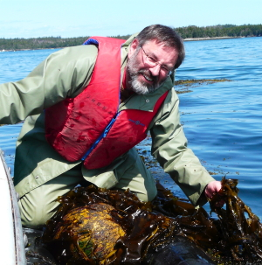
The Integrated Multi-Trophic Aquaculture (IMTA) project, co-led by Thierry Chopin (University of New Brunswick in Saint John; member of the ESIP Fisheries & Aquaculture, and Eutrophication Subcommittees) and Shawn Robinson (Fisheries and Oceans Canada St. Andrews Biological Station), and their industrial partners Cooke Aquaculture Inc. and Acadian Seaplants Limited received the 2008 Synergy Award for Innovation in the category two companies or more. This award, created in 1995, recognizes innovative collaboration between universities and industry.
Beyond the monetary value of the award ($200,000 plus the hiring of 2 industrial research and development fellows for two years for a total value of $360,000), what is most important to Thierry Chopin is the recognition that the concept promoted by his interdisciplinary team over the last 7 years is becoming more and more accepted and their tireless work is finally bearing its fruit.
Aquaculture already produces more than 40 % of the seafood consumed worldwide. To continue to supply the demand, aquaculture needs to continue to grow, but it must develop innovative, responsible, sustainable and profitable practices that will optimize its efficiency, diversify its products and help reduce the impacts of its activities. One such practice is IMTA, which combines the cultivation of fed species (fish) with that of species extracting dissolved inorganic nutrients (seaweeds) and that of species extracting the particulate organic matter (shellfish) for a balanced approach to ecosystem management.
With IMTA, part of the food and energy considered to be waste and lost in fish monoculture are reused and converted for the growth of other crops of commercial value, while allowing biomitigation to take place and substantial savings to be made on feed. That way all the components of the aquaculture system have a role in the processes and recycling services of the ecosystem. Product diversification brings economic stability and reduces risks. Environmental and economic advantages of IMTA should also contribute to an improved societal acceptance of the aquaculture industry.
“We are extremely delighted to have received this award, which clearly demonstrates that R&D in aquaculture is very competitive and can be celebrated. We are participating in the evolution of the Blue Revolution by making it greener!” says Thierry Chopin, with a big smile.
More information can be obtained at: http://www.unbsj.ca/sase/biology/chopinlab/

