January-February 2009 ESIP Journal
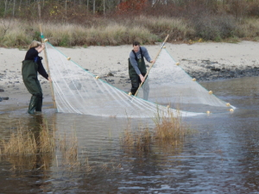
UNE Assistant Professor James Sulikowski, who is studying fish distributions within the Saco River Estuary System, pulling a beach seine with undergraduate student Kristen Kelly.

James Sulikowski, an assistant professor at the University of New England, reports on sampling efforts to investigate the fish community within the Saco River estuary system and adjacent waters.
This on-going project was initiated in the fall of 2006, and has served as a spring board for several undergraduate research projects. Dr. Sulikowski and his students have used a variety of methods to sample the Saco River area in Maine, using beam trawls, otter trawls, beach seines, gillnets, and ichthyoplankton nets.
To date, this research has yielded some surprising results. So far, fifteen species of larval fish, including cusk, which is a species of concern, and harvest fish, which is rare for this area, have been important finds in the ichthyoplankton surveys. Likewise, the surveys for macro fauna have also yielded interesting results. So far over twenty species have been identified within the estuarine portions of the river. These include Atlantic sturgeon, smelt, and blueback herring which are all considered species of concern. Even more interesting is the fact that all species captured to date have been juveniles, which suggests this geographic area may play an important role as a nursery ground.
Sulikowski s research is an important contribution to the efforts of the Gulf
of Maine Council. In Action Goal 1 (Coastal and marine habitats are in a
healthy, productive and resilient condition), the Council specifically focuses upon habitat restoration. The Council emphasizes habitats damaged by past human activities can be restored so they contribute to a properly functioning ecosystem.
What remains to be done? Dr. Sulikowski plans to continue this monitoring study for as long as possible. In addition, an acoustic array will be deployed in order to track the movement patterns of Atlantic sturgeon within the lower Saco River Watershed. This, along with deciphering the biotic and abiotic factors that are contributing to the nursery area, will keep Dr. Sulikowski and his students busy for quite some time. For more information, contact Dr. James Sulikowski at jsulikowski@une.edu.

