November-December 2008 ESIP Journal
Submitted by:
Andy Sharpe, Science Coordinator
Clean Annapolis River Project
151 Victoria Street, Annapolis Royal, Nova Scotia, Canada, B0S 1A0
902 532 7533
andysharpe@annapolisriver.ca
Garlic Mustard Management in Nova Scotia
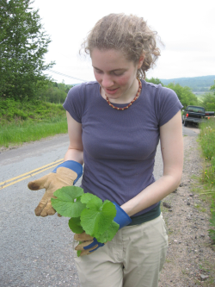
Katherine Dugas, CARP staff member, holding a pulled first year garlic mustard plant (first year plant is a rosette).

Photo Credit:
Marika Godwin, June 2008
Garlic mustard (Alliaria petiolata) is a shade-tolerant invasive alien biennial plant, originally introduced to North America from Europe. The only confirmed location of this species in Nova Scotia is in the community of Grand Pré, near Wolfville. Garlic mustard becomes established in disturbed areas, such as ditches, then spreads into undisturbed areas, including closed-canopy forests.
In the spring and summer of 2008, Clean Annapolis River Project (CARP), working with Parks Canada and the Nova Scotia Department of Transportation and Infrastructure Renewal (NSTIR), initiated a garlic mustard management project in Grand Pré. Project activities included mapping of the core and satellite garlic mustard populations, hand-pulling second-year flowering plants at satellite locations and along road side ditches, developing best management practices (BMP) for right-of-way maintenance and preparing a management plan for the garlic mustard population at Grand Pré.
The Gulf of Maine Action Plan recognizes that invasive alien species, both terrestrial and aquatic, pose a major threat to biodiversity, the integrity of ecosystems and the economy. Beyond attempting to control the spread of this invasive plant, the project sought to raise awareness in the local community of the threat posed with alien species, with 119 households being directly contacted.
Due to the reservoir of seeds within garlic mustard infestations, successful control efforts in other jurisdictions have required concerted efforts over at least three to five years. Parks Canada and the NSTIR have indicated their willingness to continue control efforts in the Grand Pré area. Over the coming months, discussions will be held with other partners to identify lead agencies for the 2009 season.
The efforts to control the garlic mustard infestation at Grand Pré has highlighted the challenges of initiating rapid and coordinated response to introductions of invasive species. Partly as a result of this experience, the Nova Scotia Invasive Species Working Group is holding a conference at Acadia University (December 3 & 4) to discuss the establishment of an Invasive Species Council for the province. For more information, contact Andy Sharpe, CARP, 902 532 7533, andysharpe@annapolisriver.ca

