December 2007-January 2008 ESIP Journal
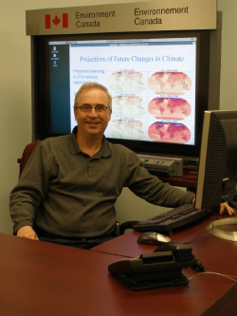
Gary Lines, Environment Canada, preparing data sets depicting future climate change. Photo Courtesy of Anne Warburton, Environment Canada, Nov 07.
In this journal entry, Gary Lines, a meteorologist with the Climate Change Section of Environment Canada Atlantic, reports on the role of climate change research in informing habitat decision-making.
“Understanding the impact of climate change has always been a collaborative research effort and that is most evident in current work on climate change indicators for the Ecosystem Indicators Partnership (ESIP). Climate researchers at the University of New Hampshire, communications experts at non-profit Clean Air Cool Planet and atmospheric scientists at Environment Canada expanded work that had begun as a study of climate trends in the Northeast United States.”
“The results covered a geographical area that included the northeast US as well as Nova Scotia, New Brunswick and Prince Edward Island thus treating that area as a unified region with respect to climatological change. Such results will help inform ecosystem managers of these changes so that it can be incorporated in planning procedures for the next 25-50 year timeframe.”
This group’s research included data supplied by Environment Canada as well as results Lines and his colleagues had generated for the Canadian Maritime Provinces. Such research is an important contribution to the efforts of the Gulf of Maine Council on the Marine Environment. In the Council’s Action Plan 2007-2012, Goal 1 (“Coastal and marine habitats are in a healthy, productive and resilient condition”) contains at least seven separate activities directly related to expanding our understanding of climate change in the marine environment.
What are the next steps for this group? The Indicator results will be expanded to include future projections and profiled to reflect changes that would direct impact on many of the Gulf of Maine habitat priorities. As Chair of the Climate Change working Group in ESIP, Mr. Lines will continue to bring the Canadian perspective to the table and collaborate with US colleagues in generating relevant results for the Gulf of Maine Marine Environment. For more information, contact Gary Lines at 902-426-5739.

